**Software Design**

**Specification**

**For**

**Exam Cell Automation**

**Prepared by Group No: 9**

**Haneen Mohammed A 32 Mereena Joseph 42 Nandana Krishna V 50 Aziyaa Subair 78**

**TABLE OF CONTENTS**

1. Introduction 3
   1. Purpose of the document 3
   2. Scope of the project 3
   3. Definitions, acronyms and abbreviations 3
   4. Overview of the document 3
2. System Architecture Description 4

2.1 Overview of modules / components 4

2.2 Structure and relationships 4

2.3 Architectural Design 5

2.4 API Integration Design 6

2.4 UML Diagram 6

2.4 Database Schema 7

2.3 User Interface 8

2.4 Mock UI 11

1. Detailed description of components 15

3.1 Component Template Description 15

3.1.1 File Preprocessing Module 15

3.1.2 Allotment Module 16

3.1.3 User Authentication and authorization Module 17

3.1.4 Malpractice Report Module 17

1. Technology Stack 18
2. Design decisions and tradeoffs 19
3. Pseudocode for components 19

**1.** **Introduction**

**1.1 Purpose of this document**

This document contains the design requirements for the Exam Cell Automation project , prepared after following several meetings and interviews with the Exam Cell of TKM College of Engineering. The objective is to implement a computerized system that automates and optimizes various administrative tasks and processes associated with managing examinations and evaluations. This system will replace the traditional manual methods of conducting exams with an automated solution that streamlines the entire process.

**1.2 Scope of the development project**

● The process of defining the high-level requirements for the exam cell automation project involves gathering input from multiple sources, including the project team and potential users. These requirements aim to capture the scope of the project and define the system's functionality, performance, and user experience.

● The high-level requirements will be used throughout the project's lifecycle to ensure that the design documents align with the project's objectives and meet stakeholder expectations. The requirements will serve as a basis for validating and verifying the design documents, ensuring that they meet the defined specifications, and identifying any potential gaps or conflicts between requirements and the design.

● This document is subject to updates or revisions during the project's duration to accommodate any changes in project requirements or scope.

**1.3 Definitions And Acronyms**

● KTU - Kerala Technical University.

● IEEE - Institute of Electrical and Electronics Engineers

**1.4 Overview of document**

The primary objective of the exam cell automation project is to transform the traditional, labor-intensive, and error-prone approach to managing examinations and evaluations by developing an automated solution that streamlines the entire process. This project seeks to achieve this goal by leveraging modern technology and software tools to optimize and automate various administrative tasks and processes

It is anticipated that the automation of these operations would increase their effectiveness, accuracy, and speed while decreasing the strain and administrative burden involved in administering tests exams.

In summary, the exam cell automation project's overarching goal is to revolutionize the traditional approach to managing examinations by implementing an automated solution that enhances efficiency, accuracy, convenience, and security.

**2. System Architecture Description**

**2.1 Overview of modules / components**

The system architecture outlines how different parts of the website will communicate with each other. The general overview of the components explains the purpose of the website . It doesn't provide specific details about individual user stories but gives an overall idea of the project requirements. This section introduces the different components and subsystems involved.

**2.2 Structure and relationships**

The three-tier architecture is a widely used software architecture that is commonly used in web-based applications. It is designed to divide an application into three distinct logical layers to enhance its scalability, modularity, and flexibility. Each layer performs specific functions that are distinct from one another, which enhances the application's overall performance.

**Presentation Layer**

The presentation layer is the first layer of the three-tier architecture. It is the user interface layer, which is responsible for presenting data to the end-users. This layer interacts directly with the end-users and provides them with an interface to interact with the application. In web-based applications, the presentation layer is typically created using HTML, CSS, and JavaScript. It communicates with the application logic layer to retrieve and process the data required for display. This layer is designed to provide a seamless user experience and is responsible for the application's look and feel.

**Application Layer**

The application logic layer is the second layer of the three-tier architecture. It contains the business logic and processes the data received from the presentation layer. This layer is responsible for performing all the application-specific operations, including data validation, calculations, and business rules.The application logic layer communicates with the presentation layer to retrieve and display the data, and it communicates with the data storage layer to retrieve and store data. This layer is designed to be independent of the presentation layer, which allows for greater modularity and flexibility.

**Data Storage Layer**

The data storage layer is the third layer of the three-tier architecture. It is responsible for storing and retrieving data from the application. This layer is typically implemented using a relational database management system (RDBMS). The data storage layer communicates with the application logic layer to store and retrieve data. It is designed to be independent of the application logic layer, which allows for greater flexibility and scalability. This layer is responsible for ensuring data integrity and security and provides a reliable and consistent data storage mechanism for the application.

**Architectural Design**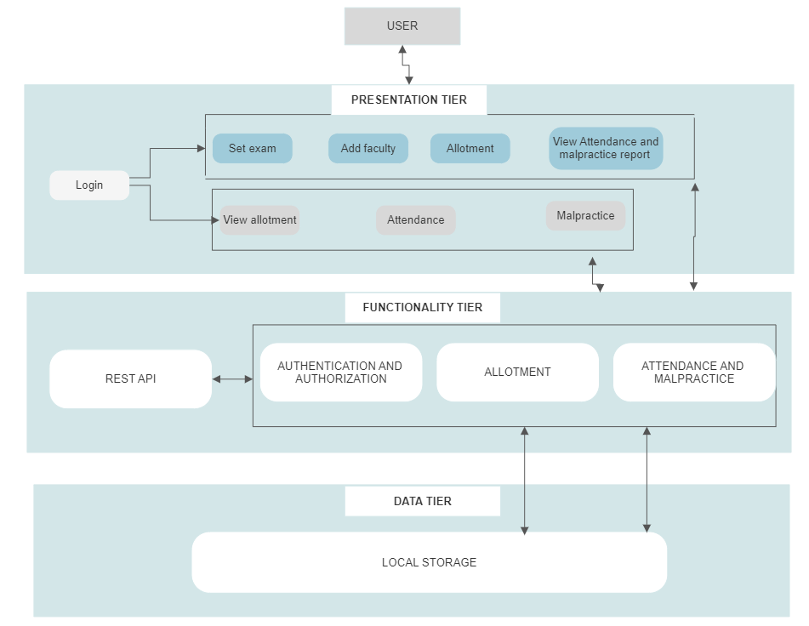

**API Integration Design**

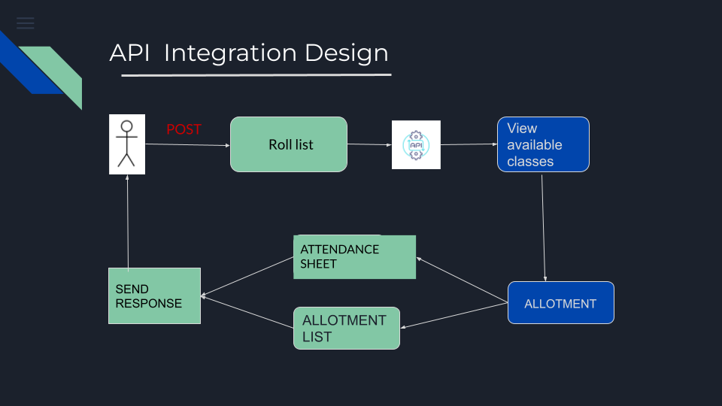

**UML DIAGRAM**

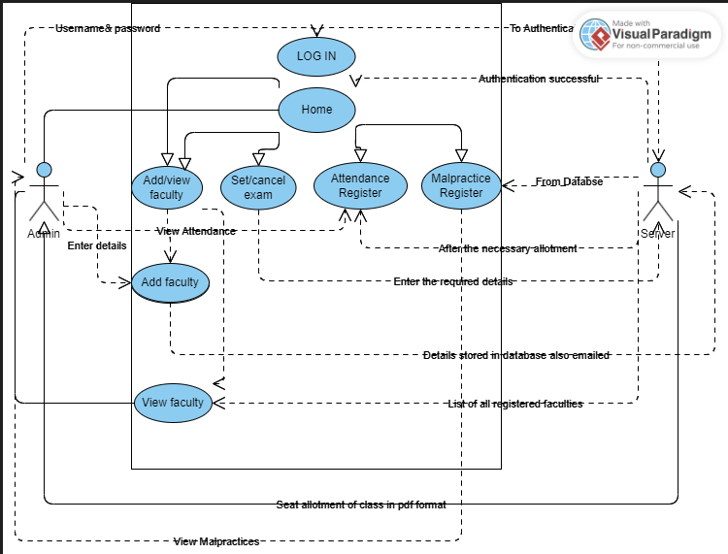

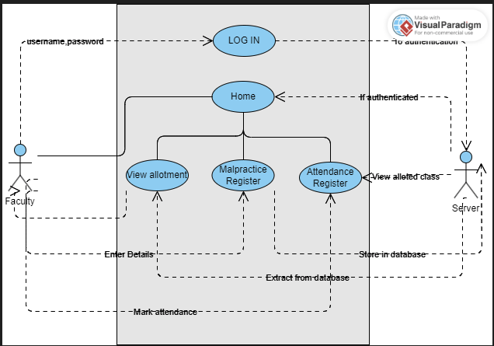

**DATABASE SCHEMA**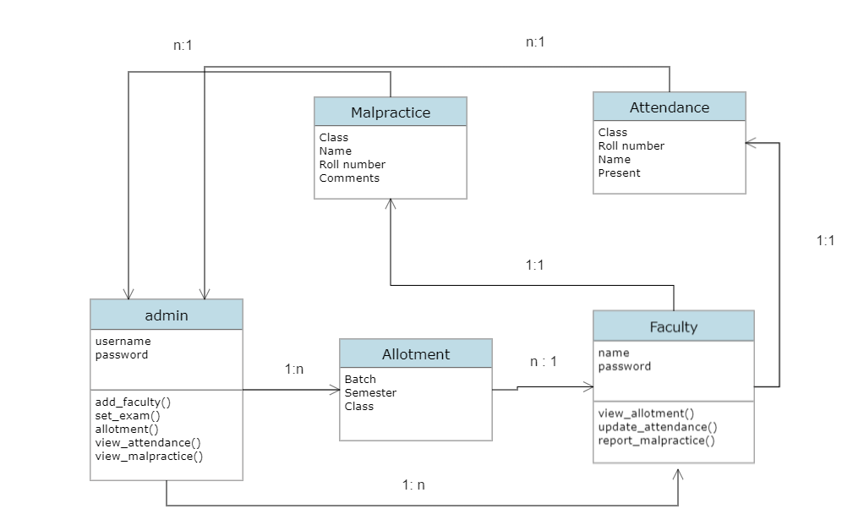

**2.3 User Interface**

* User authentication

This is to allow Exam Cell and the faculty to login into the Exam Cell Automation System.  
User enters username and password.

If they are valid and are admin, admin is taken to the admin landing page.

Else, the user is taken to the faculty landing page.

* Landing page of admin

This page lists out the functionalities that the admin can access including add faculty, set and cancel exam, allotment , view attendance and malpractice reports.

Admin logs in the website.

Click on one among the 6 buttons available in the page.

Based on the functionality selected they will be directed to different pages.

* Landing page of faculty

This page lists out the functionalities that the faculty can access including view allotment, update attendance and report malpractice.

Faculty logs in the website.

Click on one among the 3 buttons available in the page.

Based on the functionality selected they will be directed to different pages.

* Add faculty

This page is for controlling the access to the software, which is a functionality provided to ensure security of the system.

Admin on clicking the add faculty button is directed to this page.

Admin adds the details of the faculty who can access the system.

Click the submit button.

* Set exam

This page is used for setting the timetable or the exam dates based on the given branch, exam type, exam timing and semester.

Admin on clicking the set exam button is directed to this page.

Admin can add the details of the exam to be conducted

Click the submit button.

* Allotment

This page is for allotting the classes for conducting examinations.

Admin on clicking the allotment button is directed to this page.

Admin can choose branch, year and choose the classes where the exam has to be conducted.

Click the submit button.

* Attendance

This page is for viewing the attendance of students .

Admin on clicking the attendance button in the landing page is directed to this page.

Admin can choose a class and then press the submit button.

* Malpractice report

This page is for checking the malpractice report from the exam halls .

Admin on clicking the Malpractice report button in the landing page is directed to this page.

* Cancel Exam

This page is for canceling the exam.

Admin on clicking the cancel button in the landing page is directed to this page.

* View Allotment

This page is for the faculty to view the exam hall allotment.

Faculty on clicking the view allotment button in the landing page is directed to this page.

Select the class.

Press the Submit button.

* Update Attendance

This page is for the invigilator in each class to update the attendance of students attending the exam.

Faculty on selecting the Update Attendance button in the landing page is directed to this page.

Select the class.

Update the attendance of the students present in the class.

* Report malpractice

This page is for the invigilators to report  any incidences of malpractice in the exam hall.

Faculty on selecting the Report Malpractice button in the landing page is directed to this page.

Select the class.

Enter the details of the student (class, branch, roll number) and any other required  comments.

Press the Submit button.

**Mock UI**

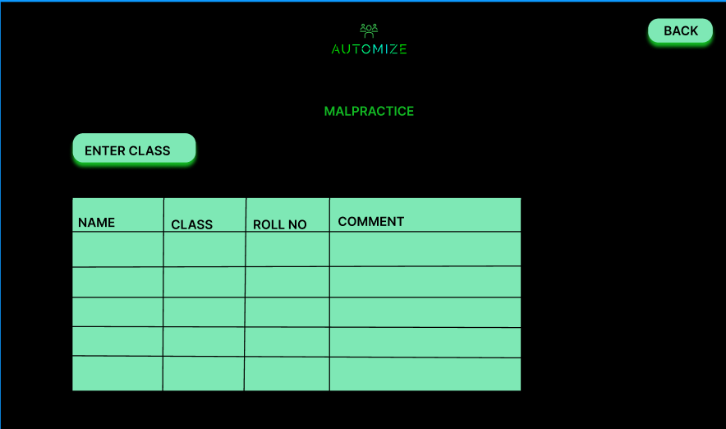

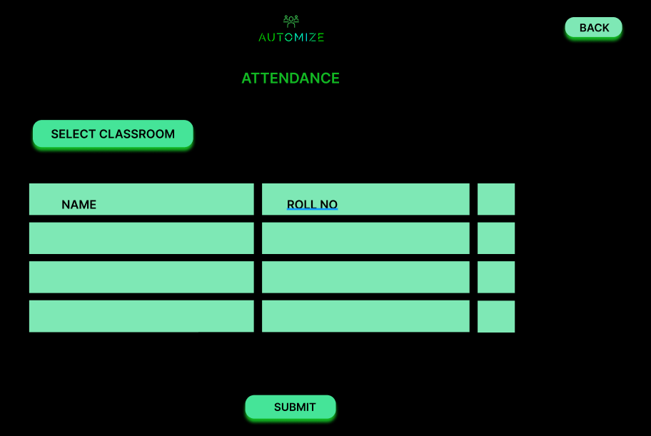

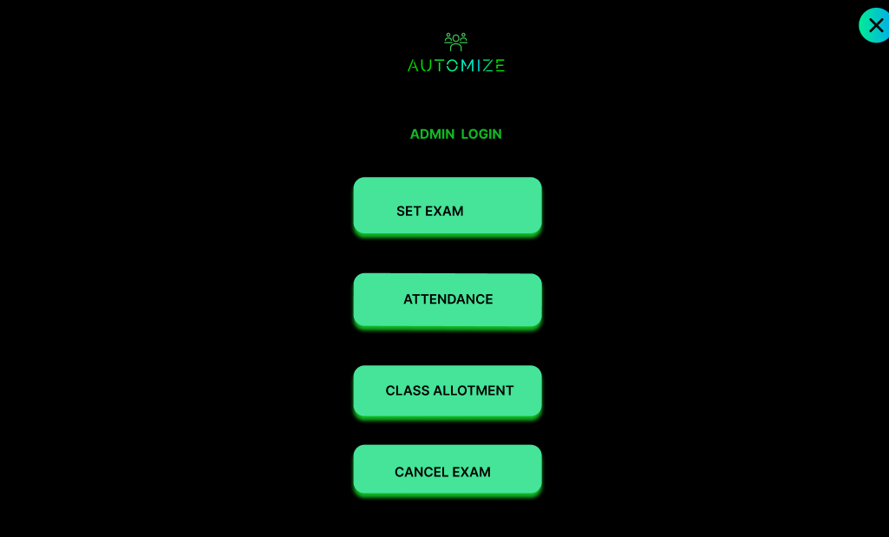

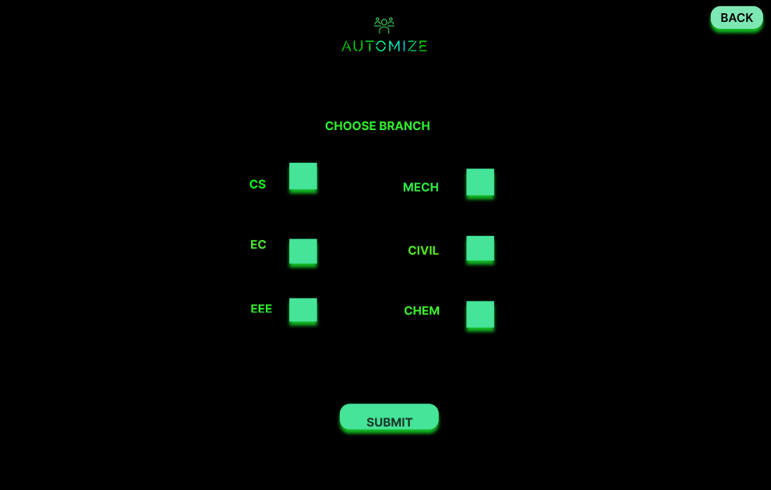

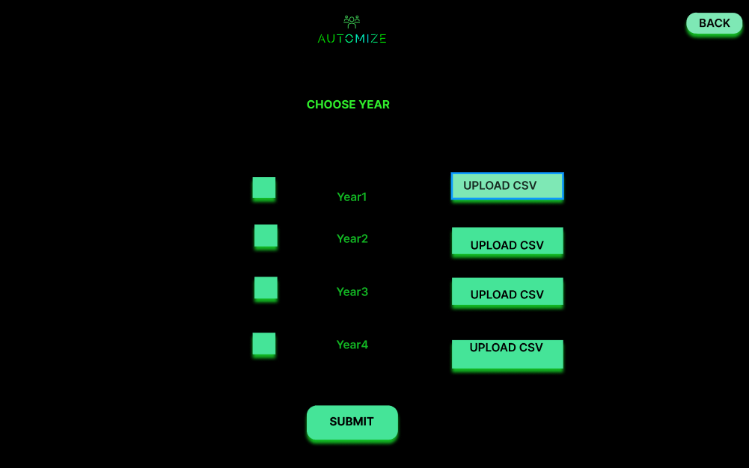

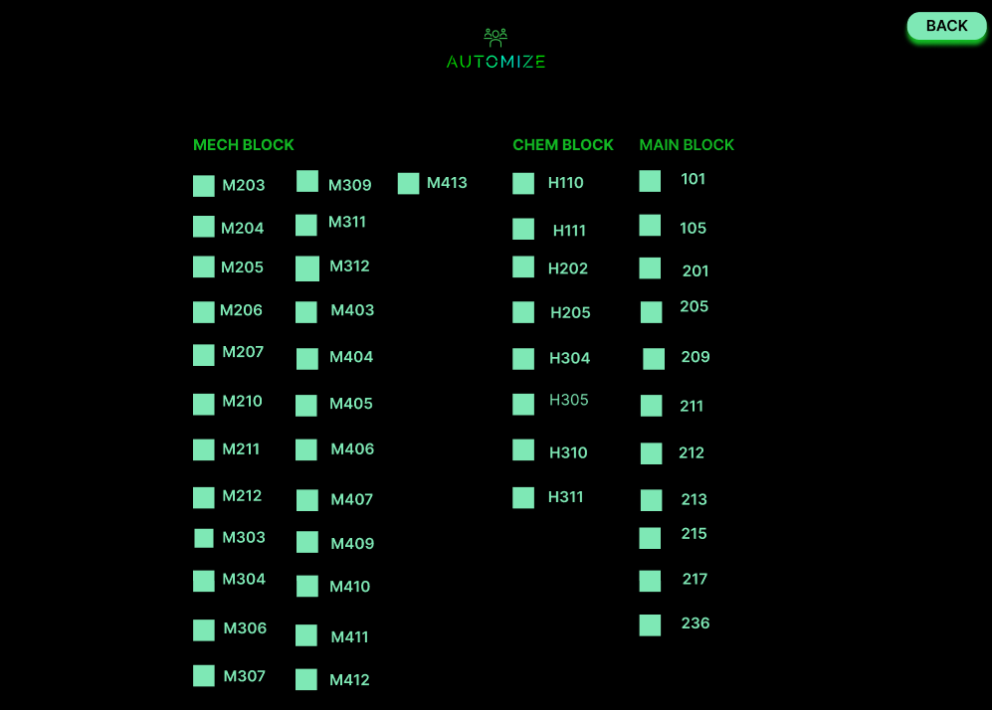

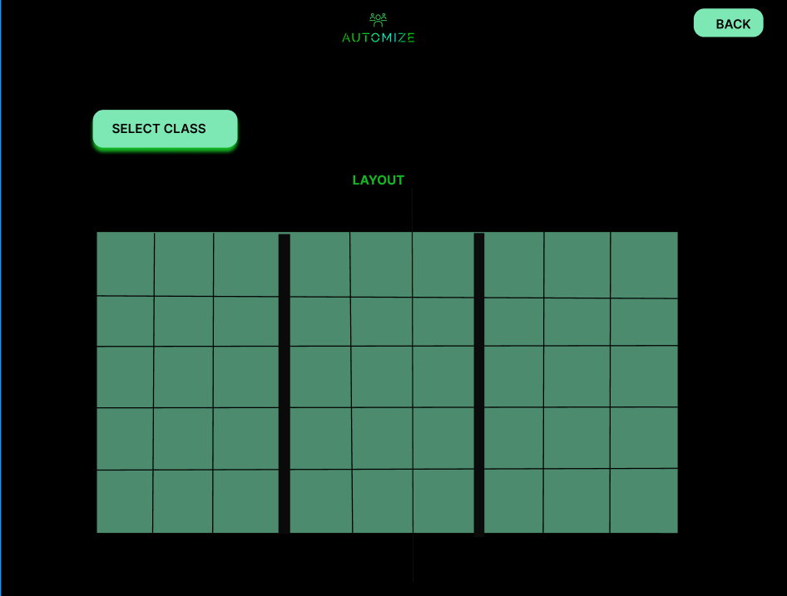



**Detailed description of components**

**3.1 Components template description**

**3.1.1 File Preprocessing Module**

| Identification | File Preprocessing Module |
| --- | --- |
| Type | A software module of the Exam Cell Automation System |
| Purpose | The purpose of the File Preprocessing Module is to retrieve the roll list of students from excel files of student data |
| Function | The function of file processing module is to take the student data excel files and retrieve the roll list |
| Subordinates | No subordinates |
| Dependencies | The details of the student data must be orderly specified |
| Interface | It interfaces with allotment module to provide the retrieved student roll list |
| Resource | It requires a computing system to process the excel file and retrieve the roll list from the student data given as input |
| Processing | File Processing Module processes the student details given as input and produces a numpy array corresponding to each batch that contains the roll list of the students |
| Data | This module takes in an excel file as input and generates numpy arrays , which are to be used by the allotment module. |

**3.1.2 Allotment Module**

| Identification | File Preprocessing Module |
| --- | --- |
| Type | A software module of the Exam Cell Automation System |
| Purpose | The purpose of the allotment module is to allot students of different classes to different halls such that no two students having the same subject won’t sit together. |
| Function | The function of the allotment module is that it should be designed to take into account the number of students, the available seats in each hall, and the subject of each student to ensure that the final seating plan is optimal and meets the requirements. |
| Subordinates | No subordinates |
| Dependencies | Depends on the file preprocessing modules |
| Interface | It interfaces with file preprocessing modules to provide the retrieved student roll list. |
| Resource | It requires a computing system to process the received roll list and allot the students according to the given list such that no two students with the same subject come together. |
| Processing | This allotment process uses python model to allot students to different classes such that no two students with the same subject come together. |
| Data | This module gets the numpy array from the file preprocessing module and makes an allotted class list based on the given data. |

**3.1.3 User Authentication and Authorization Module**

| Identification | User Authentication Module |
| --- | --- |
| Type | A software module of the Exam Cell Automation System |
| Purpose | The purpose of the User Authentication Module is to restrict the access of the website to specific individuals : exam cell and college faculty |
| Function | The function of the User Authentication Module is to ensure that only authorized users can access a system or service. By requiring users to enter a username and password, the system can verify their identity and grant access only to those who are authorized. |
| Subordinates | No subordinates |
| Dependencies | User data |
| Interface | It interfaces with user data and login |
| Resource | It requires a computing system and user data |
| Processing | User Authentication Module authenticates user credentials and manages user login |
| Data | Details of students in a class |

**3.1.4 Malpractice Report Module**

| Identification | Malpractice ReportModule |
| --- | --- |
| Type | A software module of the Exam Cell Automation System |
| Purpose | The purpose of the Malpractice Report Module is to manage the integrity of exams and promote quality of conducting exams |
| Function | The function of the Module is to ensure that exams are conducted maintaining integrity and quality. |
| Subordinates | No subordinates |
| Dependencies | Allotment data |
| Interface | It interfaces with allotment module |
| Resource | It requires a computing system and user data |
| Processing | Provide the list of students in a class and can specify any malpractices |
| Data | User data |

**4.Technology Stack**

Automize ,the Exam Cell Automation product provides efficient management of exam room allotment and attendance updation . This will reduce the manual work and time spent on making the same , if done manually.

**Functions:**

* Classroom allotment
* Attendance Updation

**Frontend:**

HTML , CSS and JavaScript,Vue.js

**Backend :**

Django

Django has been chosen because of its :

* Rapid development
* Security and scalability

**IDE used** : Visual Studio Code

**5. Design decisions and tradeoffs**

The access to the website is limited to exam cell and the college faculty. The users have to upload the student data consisting of their roll numbers and registration numbers.The features of the product include exam room allotment and attendance updation.It provides a simple user interface and is easy to handle.The website provides robus security features and access controls to ensure that only authorized users can access the system.It can handle large number of students and exam schedules.

Automated exam cell systems rely heavily on technology and can be vulnerable to system failures or cyber attacks. A disruption in the system can cause delays or errors in the exam scheduling process.The use of automation can reduce the human element in exam scheduling, which can impact the quality of interactions and the level of support provided to students and faculty members.

**6. Pseudocode for components**

# Allotment in a single class

import pandas as pd

import numpy as np

cs = pd.read_csv('CS Batch csv.csv')

ch = pd.read_csv('CH csv.csv')

allot =[['B19ROLLN ' for j in range(9)] for i in range(5)]

cs_roll = cs.iloc[:, 1]

ch_roll = ch.iloc[:, 1]

print(cs_roll)

print(ch_roll)

j = 0

k = 0

count = 0

while k<9 :

while j < 5 :

allot[j][k] = cs_roll.iloc[count]

j = j + 1

cs_roll = cs_roll.iloc[1:]

j = 0

k = k + 2

l = 0

m = 1

count = 0

while m<9 :

while l< 5 :

allot[l][m] = ch_roll.iloc[count]

l = l + 1

ch_roll = ch_roll.iloc[1:]

j = 0

l = 0

k = k + 2

m = m + 2

i=0

j=0

while i< 5 :

while j<9 :

print(allot[i][j],end = ' ')

j = j + 1

print('\n')

j = 0

i = i + 1